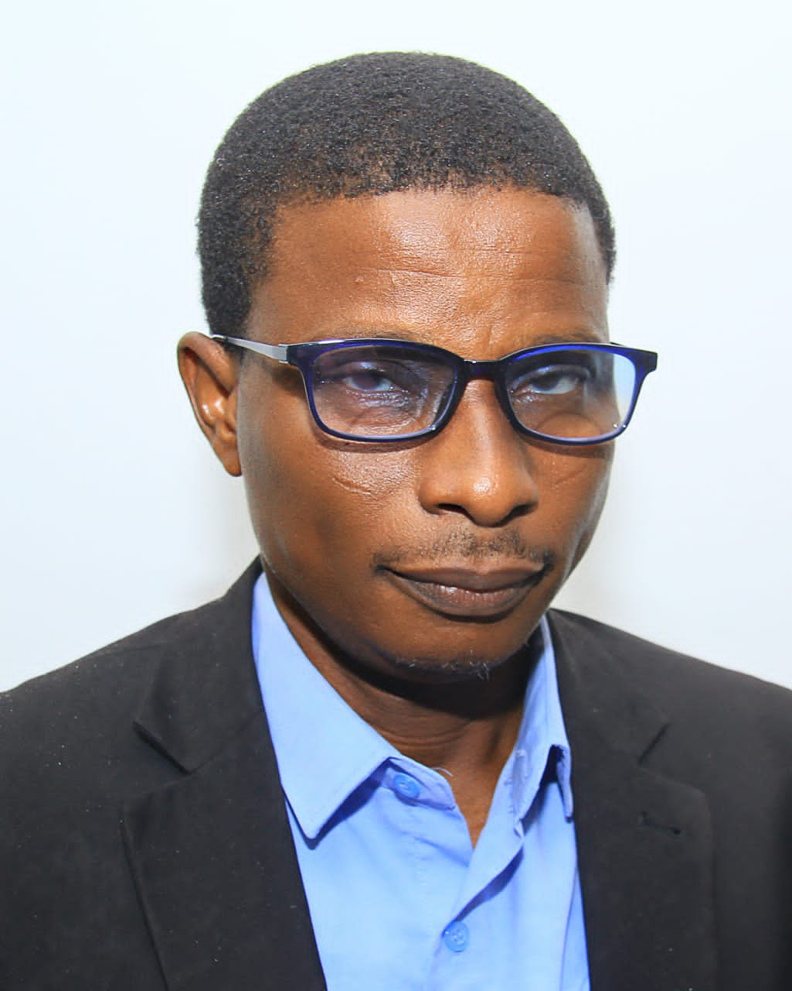

**ENGR. OLAWALE JOEL, VICE - PRESIDENT**